

_________%

48

**Year 7 HASS- Geography**

***Task 1: In Class Test (7%)***

***(Introduction to Geography and Water in the World)***

Name: ________________________ Teacher: ___________________

**Time: 5 minutes reading time and 50 minutes working time.**

**Section One: Multiple Choice**

*Read each question carefully, and circle only one option from A-D with a pencil as your response.*

**(10 marks)**

1. **What does the ‘I’ in PERTIC stand for?**
2. International
3. Interconnection
4. Infiltration
5. Intercontinental
6. **Which of the following is not a renewable resource?**
7. Solar
8. Wind
9. Coal
10. Hydroelectricity
11. **Approximately what percentage of the world’s water is fresh?**
12. 50%
13. 3%
14. 90%
15. 1%
16. **When water escapes directly from plants, it is called:**
17. Condensation
18. Infiltration
19. Transpiration
20. Precipitation

1. **Why are renewable resources important for us to manage and use?**
2. Because they are just generally better than using non-renewable resources
3. Non-renewable resources are actually better because they include coal, diamonds and uranium
4. Because water is a renewable resource, and Australia is surrounded by water
5. Because they will replenish themselves naturally over time if we do not use them too quickly
6. **During evaporation water goes from a _________________ to a ___________________.**
7. Solid, gas
8. Liquid, gas
9. Liquid, solid
10. Liquid, plasma
11. **Which of the following best describes the term ‘Geography’?**
12. The study of rights and responsibilities.
13. The study of businesses engaged in the production and trade of good and services.
14. The study of the past.
15. The study of the Earth and its features.
16. **When we examine the planet’s ability to provide resources to satisfy current needs whilst satisfying the needs of future generations, we are looking at:**
17. Sustainability
18. Environment
19. Interconnection
20. Change
21. **Which of the following does NOT belong to economical water scarcity?**
22. Not enough money invested in water infrastructure
23. Limited rainfall causing a drought
24. Water pollution caused by tourism
25. When governments do not distribute water equally among people in a country
26. **Which is NOT one of the seven geographical concepts?**
27. Place
28. Transformation
29. Change
30. Interconnection

__________________________________________________________________________________

**Section Two: Short Responses**

1. **Categorise** the list of resources below.  **(4 marks)**

|  |  |  |  |
| --- | --- | --- | --- |
| *Coal* | *Tides* | *Fish* | *Oil* |
| *Solar* | *Plants and Animals* | *Natural Gas* | *Wind* |

|  |  |  |
| --- | --- | --- |
| Renewable | Non-Renewable | Continuous |
|  |  |  |

1. **Explain** the difference between renewable and non-renewable resources.

Provide at least one example of each to support your response.

*\*Use words and phrases such as ‘on the other hand’ ‘however’ ‘for example’\** **(5 marks)**

_______________________________________________________________________________

_______________________________________________________________________________

_______________________________________________________________________________

_______________________________________________________________________________

_____________________________________________________________________________________________________________________________________________________________________________________________________________________________________________

1. Use the word bank below to assist you to **label** the Water Cycle diagram.  **(5 marks)**

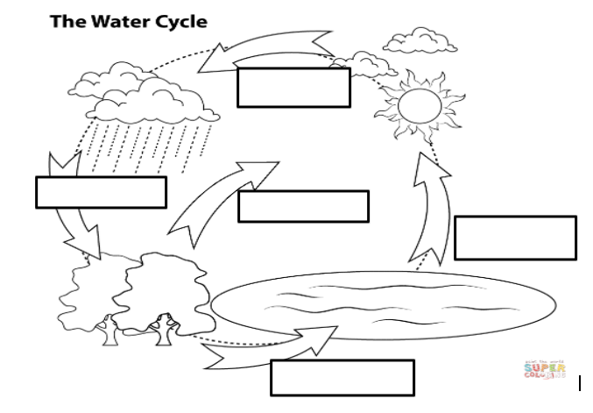

|  |  |  |
| --- | --- | --- |
| **WORD BANK** | Evaporation | Precipitation |
| Condensation | Run-off | Transpiration |

1. **State** which stage of the water cycle is missing from the diagram. **(1 mark)**

__________________________________________

1. Choose one stage of the water cycle and **define** it below. **(2 marks)**

_____________________________________________________________________________________________________________________________________________________________________________________________________________________________________________

1. **Define** the term water scarcity. You will need to include an example in your response. **(3 marks)**

______________________________________________________________________________________________________________________________________________________________

______________________________________________________________________________________________________________________________________________________________

1. **Outline** the difference between Physical and Economic water scarcity. You will need to include examples in your response. **(5 marks)**

*\*Use words and phrases such as ‘on the other hand’ ‘however’ ‘for example’\**

_____________________________________________________________________________________________________________________________________________________________________________________________________________________________________________

_____________________________________________________________________________________________________________________________________________________________________________________________________________________________________________

_____________________________________________________________________________________________________________________________________________________________________________________________________________________________________________

**Section Three: Geographical Skills – Climate Graph**

1. Complete the **climate graph** for Williams on the grid below, using the temperature and precipitation data provided in the table. Remember your labels! **(10 marks)**

|  |  |  |  |  |  |  |  |  |  |  |  |  |  |
| --- | --- | --- | --- | --- | --- | --- | --- | --- | --- | --- | --- | --- | --- |
|  | **Jan** | **Feb** | **Mar** | **Apr** | **May** | **Jun** | **Jul** | **Aug** | **Sept** | **Oct** | **Nov** | **Dec** |  |
| **Average Temperature (°C))** | 31 | 30 | 27 | 23 | 18 | 16 | 15 | 15 | 18 | 21 | 26 | 29 |  |
| **Precipitation (mm)** | 13 | 17 | 21 | 30 | 63 | 85 | 87 | 67 | 44 | 32 | 19 | 14 |  |

**Source:** Bureau of Meteorology, 2022

|  |  |  |  |  |  |  |  |  |  |  |  |  |  |
| --- | --- | --- | --- | --- | --- | --- | --- | --- | --- | --- | --- | --- | --- |
|  |  |  |  |  |  |  |  |  |  |  |  |  |  |
|  |  |  |  |  |  |  |  |  |  |  |  |  |  |
|  |  |  |  |  |  |  |  |  |  |  |  |  |  |
|  |  |  |  |  |  |  |  |  |  |  |  |  |  |
|  |  |  |  |  |  |  |  |  |  |  |  |  |  |
|  |  |  |  |  |  |  |  |  |  |  |  |  |  |
|  |  |  |  |  |  |  |  |  |  |  |  |  |  |
|  |  |  |  |  |  |  |  |  |  |  |  |  |  |
|  |  |  |  |  |  |  |  |  |  |  |  |  |  |
|  |  |  |  |  |  |  |  |  |  |  |  |  |  |
|  |  |  |  |  |  |  |  |  |  |  |  |  |  |
|  |  |  |  |  |  |  |  |  |  |  |  |  |  |
|  |  |  |  |  |  |  |  |  |  |  |  |  |  |

Use the climate graph you created to answer the questions on the following page:

1. **Identify** the warmest month(s) of the year in Williams. (1 mark)

_______________________________

1. **Identify** the month in which Williams receives the highest rainfall. (1 mark)

_______________________________

1. **True or False:** June has the coldest average temperature each year. (1 mark)

_______________________________

**END OF TEST**